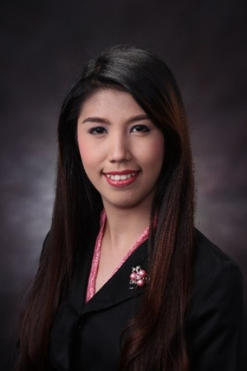**CHERRIE ANNE GARCIA TUTOR**

#035 Kamagong St., Brgy. Commonwealth, Quezon City

09279676463

[cherrie_annevgarcia@yahoo.com.ph](mailto:cherrie_annevgarcia@yahoo.com.ph)/g.cherrietutor@gmail.com

|  |
| --- |
| **Career Objective** |

To obtain a suitable position allowing me to implement and share my knowledge, experience and technical skills, as a system programmer analyst and to collaborate and work well with highly skilled professional to continue professional growth and achieve company’s attainment.

|  |
| --- |
| **Expertise** |

» Software Development Lifecycle (SDLC) » Project Management and Analyzation

» Object-Oriented Development (Java) » System Quality Testing and Maintenance

» Database Development

|  |
| --- |
| **Work Experience** |

SLI Consulting Inc. (formerly known as Software Laboratories Inc.) *June 2015 – present*

Deployed at Banco De Oro*August 2015 – present*

*Developer / Consultant*

SYSTEM NAME*: Factors Management System (WEB BASED JAVA APP)*

* Enhancing the application; front and back end.
* Creates and enhances jasper reports and MS-SQL scripts.
* Creates Web Services on client side.
* Improves security of the web application to pass Acunetix tests.
* Provide documents needed for the project such as:
  + BUSP (Business System Proposal)
  + SIT (System Unit Testing) Test Script
  + User Manual

SYSTEM NAME: Ambit Asset and Finance

* Creates Crystal Report and MS-SQL script for AAF Application
* Performs system testing using HP VUGEN Load runner
* Provide documents needed for the project such as:
  + BUSP (Business System Proposal)
  + SIT (System Unit Testing) Test Script
  + Manuals - contains steps or procedures of a certain process using the app

OTHER TASKS:

* Monitoring and Filing of Team's BUSP
* Monitoring of RT (Ticket for Production)
* Assisting User During UAT

**Additional Experience**

DIPIC Digital Pictures Imaging Corp.

*Assistant Project Manager May 2014 – May 2015*

* Supervises the machine operators and daily monitoring of their printing machines
* Performs quality checking of the artists’ and sketch up operators’ work

|  |
| --- |
| **Skills** |

**Technical Capabilities**

Language: Java, C, C++, MS-DOS, Assembly, [Batch (Windows/MS-Dos)](http://en.wikipedia.org/wiki/Batch_file)

Frameworks: Spring, Ibatis

Web Development: Servlet, JSP , javascript, jquery, jqgrid, html, css, xml, json

Databases: MS-Sql, MySql, MS Access

WebServer: Apache tomcat

Reports: Jasper, Crystal

**Professional Qualities**

* Possess a positive attitude on dealing with task efficiently.
* Capable to work in a flexible time schedule and location
* Professional, organized, and motivated individual

|  |
| --- |
| **Educational Background** |

Tertiary Education : University of the East – Caloocan

Bachelor of Science in Computer Engineering

Samson Road, Caloocan city

2009 – 2014

|  |
| --- |
| **Professional Development** |

Java Core Training : Software Laboratories Inc.

Columbia Tower, Ortigas, Mandaluyong City

|  |
| --- |
| **Personal Data** |

June 17 – July 28, 2015

Date of Birth : August 11, 1992

Place of Birth : Bacarra, Ilocos Norte

Gender : Female

Citizenship : Filipino

|  |
| --- |
| **Reference** |

Status : Married

Will be furnish upon request

*I hereby certify that the above information are true and correct to the best of my knowledge and belief.*

*_________________________________*

*Applicant's Signature*